Detection of Cyber bullying on Social Media Using Machine learning
1.INTRODUCTION
Now more than ever technology has become an integral part of our life. With the evolution of the internet. Social media is trending these days. But as all the other things misusers will pop out sometimes late sometime early but there will be for sure.Now Cyberbullying is common these days. Sites for social networking are excellent tools for communication within individuals. Use of social networking has become widespread over the years, though, in general people find immoral and unethical ways of negative stuff. We see this happening between teens or sometimes between young adults. One of the negative stuffs they do is bullying each other over the internet.In online environment we cannot easily said that whether someone is saying something just for fun or there may be other intention of him. Often,with just a joke,"or don't take it so seriously," they'll laugh it off.Cyberbullying is the use of technology to harass, threaten, embarrass, or target another person. Often this internet fight results into real life threats for some individual. Some people have turned to suicide. It is necessary to stop such activities at the beginning. Any actions could be taken to avoid this for example if an individual’s tweet/post is found offensive then maybe his/her account can be terminated or suspended for a particular period. So, what is cyberbullying?? Cyberbullying is harassment, threatening, embarrassing or targeting someone for the purpose of having fun or even by well-planned means
Objective of the Project
Cyber bullying is a major problem encountered on internet that affects teenagers and also adults. It has lead to mishappenings like suicide and depression. Regulation of content on Social media platforms has become a growing need. The following study uses data from two different forms of cyber bullying, hate speech tweets from Twitter and comments based on personal attacks from Wikipedia forums to build a model based on detection of Cyber bullying in text data using Natural Language Processing and Machine learning. Three methods for Feature extraction and four classifiers are studied to outline the best approach. For Tweet data the model provides accuracies above 90% and for Wikipedia data it gives accuracies above 80%. Keywords—Cyber bullying, Hate speech, Personal attacks, Machine learning, Feature extraction, Twitter, Wikipedia

2. LITERATURE SURVEY
“Towards the detection of cyber bullying based on social network mining techniques,”
Cyber bullying, defined as the violent harassment of an individual towards a victim in electronic media, is a serious problem nowadays. If not prevented or mitigated, it can lead to affective disorders, poor academic performance, problems in social relationships, and --- ultimately --- to suicide attempts in youngsters and children. Because manual supervision in social networks (a space where cyber bullying can naturally occur) is laborious, automated approaches for cyber bullying detection are desirable. However, a considerable number of approaches treat this problem as merely aggressive text message detection, without considering the frequency of the harassment. The approach proposed in this work, in contrast, views cyber bullying detection as a process of three consecutive stages: aggressive text message detection, alleged aggressor and victim detection, and cyberbullying case detection. This approach was tested using a dataset extracted from Twitter; the approach obtained an F-score of 0.947 for the positive (cyber bullying) case.
“Supervised machine learning for the detection of troll profiles in twitter social network: Application to a real case of cyber bullying,”
The use of new technologies along with the popularity of social networks has given the power of anonymity to the users. The ability to create an alter-ego with no relation to the actual user, creates a situation in which no one can certify the match between a profile and a real person. This problem generates situations, repeated daily, in which users with fake accounts, or at least not related to their real identity, publish news, reviews or multimedia material trying to discredit or attack other people who may or may not be aware of the attack. These acts can have great impact on the affected victims' environment generating situations in which virtual attacks escalate into fatal consequences in real life. In this article, we present a methodology to detect and associate fake profiles on Twitter social network which are employed for defamatory activities to a real profile within the same network by analysing the content of the comments generated by both profiles. Accompanying this approach we also present a successful real life use case in which this methodology was applied to detect and stop a cyber bullying situation in a real elementary school.
“Collaborative detection of cyber bullying behaviour in Twitter data,”
As the size of Twitter© data is increasing, so are undesirable behaviors of its users. One of such undesirable behavior is cyberbullying, which may even lead to catastrophic consequences. Hence, it is critical to efficiently detect cyberbullying behavior by analyzing tweets, if possible in realtime. Prevalent approaches to identify cyberbullying are mainly stand-alone and thus, are time-consuming. This research improves detection task using the principles of collaborative computing. Different collaborative paradigms are suggested and discussed in this paper. Preliminary results indicate an improvement in time and accuracy of the detection mechanism over the stand-alone paradigm
“Automatic detection of cyber bullying on social networks based on bullying features,”
With the increasing use of social media, cyber bullying behaviour has received more and more attention. Cyber bullying may cause many serious and negative impacts on a person's life and even lead to teen suicide. To reduce and stop cyber bullying, one effective solution is to automatically detect bullying content based on appropriate machine learning and natural language processing techniques. However, many existing approaches in the literature are just normal text classification models without considering bullying characteristics. In this paper, we propose a representation learning framework specific to cyber bullying detection. Based on word embeddings, we expand a list of pre-defined insulting words and assign different weights to obtain bullying features , which are then concatenated with Bag-of-Words and latent semantic features to form the final representation before feeding them into a linear SVM classifier. Experimental study on a twitter dataset is conducted, and our method is compared with several baseline text representation learning models and cyber bullying detection methods. The superior performance achieved by our method has been observed in this study.
“Detection of Cyberbullying Using Deep Neural Network,”
Innovation is developing quickly today. This headways in innovation has changed how individuals cooperate in an expansive way giving communication another dimension. But despite the fact that innovation encourages us in numerous parts of life, it accompanies different effects that influence people in a few or the other way. Cyberbullying is one of such effects. Cyberbullying is a wrongdoing in which a culprit focuses on an individual with online provocation and loathe which has antagonistic emotional, social and physical effects on the victim. So as to address such issue we proposed a novel cyberbullying detection method dependent on deep neural network. Convolution Neural Network is utilized for the better outcomes when contrasted with the current systems
“Using machine learning to detect cyber bullying,”
Cyber bullying is the use of technology as a medium to bully someone. Although it has been an issue for many years, the recognition of its impact on young people has recently increased. Social networking sites provide a fertile medium for bullies, and teens and young adults who use these sites are vulnerable to attacks. Through machine learning, we can detect language patterns used by bullies and their victims, and develop rules to automatically detect cyber bullying content. The data we used for our project was collected from the website Formspring.me, a question-and-answer formatted website that contains a high percentage of bullying content. The data was labeled using a web service, Amazon's Mechanical Turk. We used the labeled data, in conjunction with machine learning techniques provided by the Weka tool kit, to train a computer to recognize bullying content. Both a C4.5 decision tree learner and an instance-based learner were able to identify the true positives with 78.5% accuracy.
“Cyber bullying Detection using Pre-Trained BERT Model,”
Cyberbullying is spread across various social media platforms. It is a wrong deed in which the victim is harassed by receiving the derogatory / provocative / sensitive images or text messages by the bully. Detection of such message/post in such large platforms is very difficult and may sometimes lead to false detection. Recently, deep neural network based models have shown significant improvement over traditional models in detecting cyberbullying. Also, new and more complex deep learning architectures are being developed which are proving to be useful in various NLP tasks. Google researchers has recently developed a language learning model called BERT, which is capable of generating contextual embeddings and is also able to produce task specific embeddings for classification. A new approach is proposed to cyberbullying detection in social media platforms by using the novel pre-trained BERT model with a single linear neural network layer on top as a classifier, which improves over the existing results. The model is trained and evaluated on two social media datasets of which one dataset is small size and the second dataset is relatively larger size.
“Cyber bullying Detection in Social Networks Using Deep Learning Based Models; A Reproducibility Study,”
Cyberbullying is a disturbing online misbehaviour with troubling consequences. It appears in different forms, and in most of the social networks, it is in textual format. Automatic detection of such incidents requires intelligent systems. Most of the existing studies have approached this problem with conventional machine learning models and the majority of the developed models in these studies are adaptable to a single social network at a time. In recent studies, deep learning based models have found their way in the detection of cyberbullying incidents, claiming that they can overcome the limitations of the conventional models, and improve the detection performance. In this paper, we investigate the findings of a recent literature in this regard. We successfully reproduced the findings of this literature and validated their findings using the same datasets, namely Wikipedia, Twitter, and Formspring, used by the authors. Then we expanded our work by applying the developed methods on a new YouTube dataset (~54k posts by ~4k users) and investigated the performance of the models in new social media platforms. We also transferred and evaluated the performance of the models trained on one platform to another platform. Our findings show that the deep learning based models outperform the machine learning models previously applied to the same YouTube dataset. We believe that the deep learning based models can also benefit from integrating other sources of information and looking into the impact of profile information of the users in social networks.
“Deep learning for detecting cyberbullying across multiple social media platforms,”
Harassment by cyberbullies is a significant phenomenon on the social media. Existing works for cyberbullying detection have at least one of the following three bottlenecks. First, they target only one particular social media platform (SMP). Second, they address just one topic of cyberbullying. Third, they rely on carefully handcrafted features of the data. We show that deep learning based models can overcome all three bottlenecks. Knowledge learned by these models on one dataset can be transferred to other datasets. We performed extensive experiments using three real-world datasets: Formspring (∼∼12k posts), Twitter (∼∼16k posts), and Wikipedia(∼∼100k posts). Our experiments provide several useful insights about cyberbullying detection. To the best of our knowledge, this is the first work that systematically analyzes cyberbullying detection on various topics across multiple SMPs using deep learning based models and transfer learning.
“Bully Blocker: Towards the identification of cyber bullying in social networking sites,”
Cyberbullying is the deliberate use of online digital media to communicate false, embarrassing, or hostile information about another person. It is the most common online risk for adolescents and well over half of young people do not tell their parents when it occurs. While there have been many studies about the nature and prevalence of cyberbullying, there has been relatively less work in the area of automated identification of cyberbullying in social media sites. The focus of our work is to develop an automated model to identify and measure the degree of cyberbullying in social networking sites, and a Facebook app for parents, built on this model, that notifies them when cyberbullying occurs. This paper describes the challenges associated with building a computer model for cyberbullying identification, presents key results from psychology research that can be used in such a model, describes an initial model and mobile app design for cyberbullying identification, and describes key areas of future work to improve upon the initial model.
3. SYSTEM ANALYSIS
3.1 EXISTING SYSTEM
In Existing system, we are using Random Forest and KNN. But using this algorithms we cannot predict cyber bully from user post messages correctly. Random Forest algorithm is unable to predict sentiments also.
Disadvantage
1. Less Prediction.
2.Security is less.
3.2 PROPOSED SYSTEM
In this project as per your request we have used given dataset to train machine learning algorithms such as ADABOOST, Multinomial Naïve Bayes and SGD to predict cyber bully from user post messages. SVM classifier is used to predict sentiments.
Advantage
1. Security is more.
2. More Prediction.

MODULES
This project consists of two users
- Admin user: admin can login to application by using username and password as ‘admin’ and ‘admin’. After login admin can view list of users and their count of offensive messages posted by them. If count is more than 2 then Block linked will get activated and then admin will block him. Admin can view accuracy and other metrics from trained model.
2)User: user can sign up with the application and then can login and then can upload post. While uploading application will detect sentiments and check for offensive words
3.3. PROCESS MODEL USED WITH JUSTIFICATION
SDLC (Umbrella Model):
Umbrella Activity
Umbrella Activity
Umbrella Activity
- Feasibility Study
- TEAM FORMATION
- Project Specification PREPARATION

Business Requirement Documentation
ANALYSIS & DESIGN
CODE
UNIT TEST
DOCUMENT CONTROL

ASSESSMENT

TRAINING
INTEGRATION & SYSTEM TESTING

DELIVERY/INSTALLATION
ACCEPTANCE TEST
Requirements Gathering
SDLC is nothing but Software Development Life Cycle. It is a standard which is used by software industry to develop good software.
Stages in SDLC:
- Requirement Gathering
- Analysis
- Designing
- Coding
- Testing
- Maintenance
Requirements Gathering stage:
The requirements gathering process takes as its input the goals identified in the high-level requirements section of the project plan. Each goal will be refined into a set of one or more requirements. These requirements define the major functions of the intended application, define operational data areas and reference data areas, and define the initial data entities. Major functions include critical processes to be managed, as well as mission critical inputs, outputs and reports. A user class hierarchy is developed and associated with these major functions, data areas, and data entities. Each of these definitions is termed a Requirement. Requirements are identified by unique requirement identifiers and, at minimum, contain a requirement title and textual description.
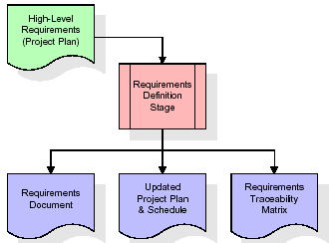
These requirements are fully described in the primary deliverables for this stage: the Requirements Document and the Requirements Traceability Matrix (RTM). The requirements document contains complete descriptions of each requirement, including diagrams and references to external documents as necessary. Note that detailed listings of database tables and fields are not included in the requirements document.
The title of each requirement is also placed into the first version of the RTM, along with the title of each goal from the project plan. The purpose of the RTM is to show that the product components developed during each stage of the software development lifecycle are formally connected to the components developed in prior stages.
In the requirements stage, the RTM consists of a list of high-level requirements, or goals, by title, with a listing of associated requirements for each goal, listed by requirement title. In this hierarchical listing, the RTM shows that each requirement developed during this stage is formally linked to a specific product goal. In this format, each requirement can be traced to a specific product goal, hence the term requirements traceability.
The outputs of the requirements definition stage include the requirements document, the RTM, and an updated project plan.
- Feasibility study is all about identification of problems in a project.
- No. of staff required to handle a project is represented as Team Formation, in this case only modules are individual tasks will be assigned to employees who are working for that project.
- Project Specifications are all about representing of various possible inputs submitting to the server and corresponding outputs along with reports maintained by administrator.
Analysis Stage:
The planning stage establishes a bird's eye view of the intended software product, and uses this to establish the basic project structure, evaluate feasibility and risks associated with the project, and describe appropriate management and technical approaches.
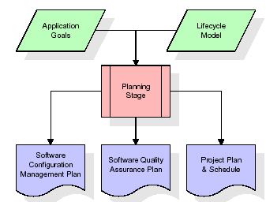
The most critical section of the project plan is a listing of high-level product requirements, also referred to as goals. All of the software product requirements to be developed during the requirements definition stage flow from one or more of these goals. The minimum information for each goal consists of a title and textual description, although additional information and references to external documents may be included. The outputs of the project planning stage are the configuration management plan, the quality assurance plan, and the project plan and schedule, with a detailed listing of scheduled activities for the upcoming Requirements stage, and high level estimates of effort for the out stages.
Designing Stage:
The design stage takes as its initial input the requirements identified in the approved requirements document. For each requirement, a set of one or more design elements will be produced as a result of interviews, workshops, and/or prototype efforts. Design elements describe the desired software features in detail, and generally include functional hierarchy diagrams, screen layout diagrams, tables of business rules, business process diagrams, pseudo code, and a complete entity-relationship diagram with a full data dictionary. These design elements are intended to describe the software in sufficient detail that skilled programmers may develop the software with minimal additional input.

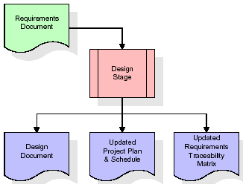
When the design document is finalized and accepted, the RTM is updated to show that each design element is formally associated with a specific requirement. The outputs of the design stage are the design document, an updated RTM, and an updated project plan.
Development (Coding) Stage:
The development stage takes as its primary input the design elements described in the approved design document. For each design element, a set of one or more software artefacts will be produced. Software artefacts include but are not limited to menus, dialogs, and data management forms, data reporting formats, and specialized procedures and functions. Appropriate test cases will be developed for each set of functionally related software artefacts, and an online help system will be developed to guide users in their interactions with the software.
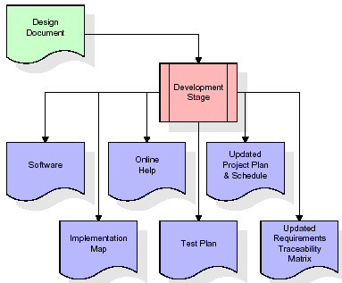

The RTM will be updated to show that each developed artefact is linked to a specific design element, and that each developed artefact has one or more corresponding test case items. At this point, the RTM is in its final configuration. The outputs of the development stage include a fully functional set of software that satisfies the requirements and design elements previously documented, an online help system that describes the operation of the software, an implementation map that identifies the primary code entry points for all major system functions, a test plan that describes the test cases to be used to validate the correctness and completeness of the software, an updated RTM, and an updated project plan.
Integration & Test Stage:
During the integration and test stage, the software artefacts, online help, and test data are migrated from the development environment to a separate test environment. At this point, all test cases are run to verify the correctness and completeness of the software. Successful execution of the test suite confirms a robust and complete migration capability. During this stage, reference data is finalized for production use and production users are identified and linked to their appropriate roles. The final reference data (or links to reference data source files) and production user list are compiled into the Production Initiation Plan.
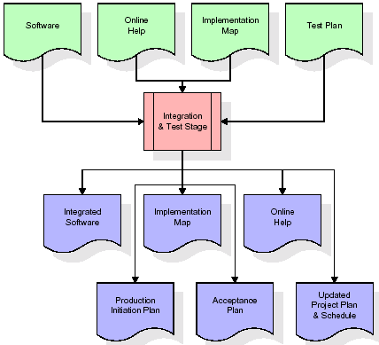
The outputs of the integration and test stage include an integrated set of software, an online help system, an implementation map, a production initiation plan that describes reference data and production users, an acceptance plan which contains the final suite of test cases, and an updated project plan.
- Installation & Acceptance Test:
During the installation and acceptance stage, the software artefacts, online help, and initial production data are loaded onto the production server. At this point, all test cases are run to verify the correctness and completeness of the software. Successful execution of the test suite is a prerequisite to acceptance of the software by the customer.
After customer personnel have verified that the initial production data load is correct and the test suite has been executed with satisfactory results, the customer formally accepts the delivery of the software.
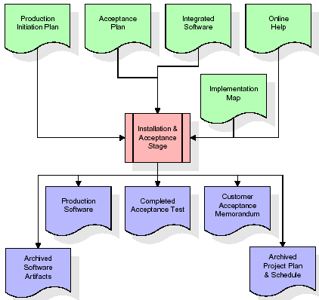
The primary outputs of the installation and acceptance stage include a production application, a completed acceptance test suite, and a memorandum of customer acceptance of the software. Finally, the PDR enters the last of the actual labor data into the project schedule and locks the project as a permanent project record. At this point the PDR "locks" the project by archiving all software items, the implementation map, the source code, and the documentation for future reference.
Maintenance:
Outer rectangle represents maintenance of a project, Maintenance team will start with requirement study, understanding of documentation later employees will be assigned work and they will undergo training on that particular assigned category. For this life cycle there is no end, it will be continued so on like an umbrella (no ending point to umbrella sticks).
3.4. Software Requirement Specification
3.4.1. Overall Description
A Software Requirements Specification (SRS) – a requirements specification for a software system is a complete description of the behaviour of a system to be developed. It includes a set of use cases that describe all the interactions the users will have with the software. In addition to use cases, the SRS also contains non-functional requirements. Non-functional requirements are requirements which impose constraints on the design or implementation (such as performance engineering requirements, quality standards, or design constraints).
System requirements specification: A structured collection of information that embodies the requirements of a system. A business analyst, sometimes titled system analyst, is responsible for analyzing the business needs of their clients and stakeholders to help identify business problems and propose solutions. Within the systems development lifecycle domain, the BA typically performs a liaison function between the business side of an enterprise and the information technology department or external service providers. Projects are subject to three sorts of requirements:
- Business requirements describe in business terms what must be delivered or accomplished to provide value.
- Product requirements describe properties of a system or product (which could be one of several ways to accomplish a set of business requirements.)
- Process requirements describe activities performed by the developing organization. For instance, process requirements could specify .Preliminary investigation examine project feasibility, the likelihood the system will be useful to the organization. The main objective of the feasibility study is to test the Technical, Operational and Economical feasibility for adding new modules and debugging old running system. All system is feasible if they are unlimited resources and infinite time. There are aspects in the feasibility study portion of the preliminary investigation:

- ECONOMIC FEASIBILITY
A system can be developed technically and that will be used if installed must still be a good investment for the organization. In the economical feasibility, the development cost in creating the system is evaluated against the ultimate benefit derived from the new systems. Financial benefits must equal or exceed the costs. The system is economically feasible. It does not require any addition hardware or software. Since the interface for this system is developed using the existing resources and technologies available at NIC, There is nominal expenditure and economical feasibility for certain.
- Operational Feasibility
Proposed projects are beneficial only if they can be turned out into information system. That will meet the organization’s operating requirements. Operational feasibility aspects of the project are to be taken as an important part of the project implementation. This system is targeted to be in accordance with the above-mentioned issues. Beforehand, the management issues and user requirements have been taken into consideration. So there is no question of resistance from the users that can undermine the possible application benefits. The well-planned design would ensure the optimal utilization of the computer resources and would help in the improvement of performance status.
- TECHNICAL FEASIBILITY
Earlier no system existed to cater to the needs of ‘Secure Infrastructure Implementation System’. The current system developed is technically feasible. It is a web based user interface for audit workflow at NIC-CSD. Thus it provides an easy access to .the users. The database’s purpose is to create, establish and maintain a workflow among various entities in order to facilitate all concerned users in their various capacities or roles. Permission to the users would be granted based on the roles specified. Therefore, it provides the technical guarantee of accuracy, reliability and security.
3.4.2. External Interface Requirements
User Interface
The user interface of this system is a user friendly python Graphical User Interface.
Hardware Interfaces
The interaction between the user and the console is achieved through python capabilities.
Software Interfaces
The required software is python.
HARDWARE REQUIREMENTS:

Processor - Intel I3(min)
- Speed - 1.1 GHz
- RAM - 4GB (min)
- Hard Disk - 500GB (min)
SOFTWARE REQUIREMENTS:
- Operating System - Windows 10/above
- Programming Language - Python 3.7.0

4. SYSTEM DESIGN
UML Diagram:
The Unified Modelling Language allows the software engineer to express an analysis model using the modelling notation that is governed by a set of syntactic semantic and pragmatic rules.
A UML system is represented using five different views that describe the system from distinctly different perspective. Each view is defined by a set of diagram, which is as follows.
User Model View
- This view represents the system from the users perspective.
- The analysis representation describes a usage scenario from the end-users perspective.
Structural Model view
- In this model the data and functionality are arrived from inside the system.
- This model view models the static structures.
Behavioural Model View
It represents the dynamic of behavioural as parts of the system, depicting the interactions of collection between various structural elements described in the user model and structural model view.
Implementation Model View
In this the structural and behavioural as parts of the system are represented as they are to be built.
Environmental Model View
In this the structural and behavioural aspects of the environment in which the system is to be implemented are represented.
Class Diagram:
The class diagram is the main building block of object oriented modeling. It is used both for general conceptual modeling of the systematic of the application, and for detailed modeling translating the models into programming code. Class diagrams can also be used for data modeling. The classes in a class diagram represent both the main objects, interactions in the application and the classes to be programmed. In the diagram, classes are represented with boxes which contain three parts:
- The upper part holds the name of the class
- The middle part contains the attributes of the class
- The bottom part gives the methods or operations the class can take or undertake

Use case Diagram:
A use case diagram at its simplest is a representation of a user's interaction with the system and depicting the specifications of a use case. A use case diagram can portray the different types of users of a system and the various ways that they interact with the system. This type of diagram is typically used in conjunction with the textual use case and will often be accompanied by other types of diagrams as well.

Sequence diagram:
A sequence diagram is a kind of interaction diagram that shows how processes operate with one another and in what order. It is a construct of a Message Sequence Chart. A sequence diagram shows object interactions arranged in time sequence. It depicts the objects and classes involved in the scenario and the sequence of messages exchanged between the objects needed to carry out the functionality of the scenario. Sequence diagrams are typically associated with use case realizations in the Logical View of the system under development. Sequence diagrams are sometimes called event diagrams, event scenarios, and timing diagrams.

Collaboration diagram:
A collaboration diagram describes interactions among objects in terms of sequenced messages. Collaboration diagrams represent a combination of information taken from class, sequence, and use case diagrams describing both the static structure and dynamic behaviour of a system.

Component Diagram:
In the Unified Modelling Language, a component diagram depicts how components are wired together to form larger components and or software systems. They are used to illustrate the structure of arbitrarily complex systems.
Components are wired together by using an assembly connector to connect the required interface of one component with the provided interface of another component. This illustrates the service consumer - service provider relationship between the two components.

Deployment Diagram:
A deployment diagram in the Unified Modeling Language models the physical deployment of artifacts on nodes. To describe a web site, for example, a deployment diagram would show what hardware components ("nodes") exist (e.g., a web server, an application server, and a database server), what software components ("artifacts") run on each node (e.g., web application, database), and how the different pieces are connected (e.g. JDBC, REST, RMI).
The nodes appear as boxes, and the artifacts allocated to each node appear as rectangles within the boxes. Nodes may have sub nodes, which appear as nested boxes. A single node in a deployment diagram may conceptually represent multiple physical nodes, such as a cluster of database servers.
Activity Diagram:
Activity diagram is another important diagram in UML to describe dynamic aspects of the system. It is basically a flow chart to represent the flow form one activity to another activity. The activity can be described as an operation of the system. So the control flow is drawn from one operation to another. This flow can be sequential, branched or concurrent
USER:
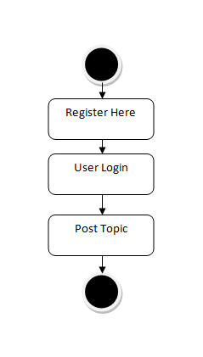

Admin User:
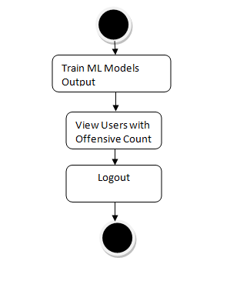

Data Flow Diagram:
Data flow diagrams illustrate how data is processed by a system in terms of inputs and outputs. Data flow diagrams can be used to provide a clear representation of any business function. The technique starts with an overall picture of the business and continues by analyzing each of the functional areas of interest. This analysis can be carried out in precisely the level of detail required. The technique exploits a method called top-down expansion to conduct the analysis in a targeted way.
As the name suggests, Data Flow Diagram (DFD) is an illustration that explicates the passage of information in a process. A DFD can be easily drawn using simple symbols. Additionally, complicated processes can be easily automated by creating DFDs using easy-to-use, free downloadable diagramming tools. A DFD is a model for constructing and analyzing information processes. DFD illustrates the flow of information in a process depending upon the inputs and outputs. A DFD can also be referred to as a Process Model. A DFD demonstrates business or technical process with the support of the outside data saved, plus the data flowing from the process to another and the end results

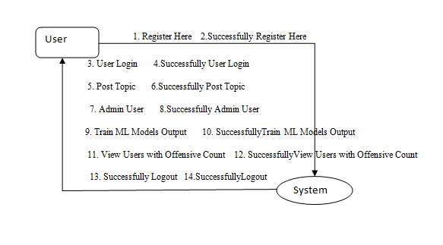

5. IMPLEMETATION
5.1 Python
Python is a general-purpose language. It has wide range of applications from Web development (like: Django and Bottle), scientific and mathematical computing (Orange, SymPy, NumPy) to desktop graphical user Interfaces (Pygame, Panda3D). The syntax of the language is clean and length of the code is relatively short. It's fun to work in Python because it allows you to think about the problem rather than focusing on the syntax.
History of Python:
Python is a fairly old language created by Guido Van Rossum. The design began in the late 1980s and was first released in February 1991.
Why Python was created?
In late 1980s, Guido Van Rossum was working on the Amoeba distributed operating system group. He wanted to use an interpreted language like ABC (ABC has simple easy-to-understand syntax) that could access the Amoeba system calls. So, he decided to create a language that was extensible. This led to design of a new language which was later named Python.
Why the name Python?
No. It wasn't named after a dangerous snake. Rossum was fan of a comedy series from late seventies. The name "Python" was adopted from the same series "Monty Python's Flying Circus".
Features of Python:
A simple language which is easier to learn
Python has a very simple and elegant syntax. It's much easier to read and write Python programs compared to other languages like: C++, Java, C#. Python makes programming fun and allows you to focus on the solution rather than syntax.
If you are a newbie, it's a great choice to start your journey with Python.
Free and open-source
You can freely use and distribute Python, even for commercial use. Not only can you use and distribute software’s written in it, you can even make changes to the Python's source code.
Python has a large community constantly improving it in each iteration.
Portability
You can move Python programs from one platform to another, and run it without any changes.
It runs seamlessly on almost all platforms including Windows, Mac OS X and Linux.
Extensible and Embeddable
Suppose an application requires high performance. You can easily combine pieces of C/C++ or other languages with Python code.
This will give your application high performance as well as scripting capabilities which other languages may not provide out of the box.
A high-level, interpreted language
Unlike C/C++, you don't have to worry about daunting tasks like memory management, garbage collection and so on.
Likewise, when you run Python code, it automatically converts your code to the language your computer understands. You don't need to worry about any lower-level operations.
Large standard libraries to solve common tasks
Python has a number of standard libraries which makes life of a programmer much easier since you don't have to write all the code yourself. For example: Need to connect MySQL database on a Web server? You can use MySQLdb library using import MySQLdb .
Standard libraries in Python are well tested and used by hundreds of people. So you can be sure that it won't break your application.
Object-oriented
Everything in Python is an object. Object oriented programming (OOP) helps you solve a complex problem intuitively.
With OOP, you are able to divide these complex problems into smaller sets by creating objects.

Applications of Python:
1. Simple Elegant Syntax
Programming in Python is fun. It's easier to understand and write Python code. Why? The syntax feels natural. Take this source code for an example:
a = 2
b = 3
sum = a + b
print(sum)
2. Not overly strict
You don't need to define the type of a variable in Python. Also, it's not necessary to add semicolon at the end of the statement.
Python enforces you to follow good practices (like proper indentation). These small things can make learning much easier for beginners.
3. Expressiveness of the language
Python allows you to write programs having greater functionality with fewer lines of code. Here's a link to the source code of Tic-tac-toe game with a graphical interface and a smart computer opponent in less than 500 lines of code. This is just an example. You will be amazed how much you can do with Python once you learn the basics.
4. Great Community and Support
Python has a large supporting community. There are numerous active forums online which can be handy if you are stuck.
5.2 Sample Code:
from django.shortcuts import render
from django.template import RequestContext
from django.contrib import messages
import pymysql
from django.http import HttpResponse
from django.core.files.storage import FileSystemStorage
import os
from sklearn.externals import joblib
import random
from datetime import date

from sklearn.metrics import accuracy_score
from sklearn.model_selection import train_test_split
from string import punctuation
from nltk.corpus import stopwords
import nltk
from nltk.stem import WordNetLemmatizer
from sklearn.feature_extraction.text import TfidfVectorizer
import numpy as np
import pandas as pd
import pickle
from nltk.stem import PorterStemmer
from sklearn.ensemble import AdaBoostClassifier
from sklearn.linear_model import SGDClassifier
from sklearn.naive_bayes import MultinomialNB
from sklearn.metrics import accuracy_score
from sklearn.metrics import precision_score
from sklearn.metrics import recall_score
from sklearn.metrics import f1_score
import matplotlib.pyplot as plt

load_index = 0
global svm_classifier, user_status, sgd
stop_words = set(stopwords.words('english'))
lemmatizer = WordNetLemmatizer()
ps = PorterStemmer()

accuracy = []
precision = []
recall = []
fscore = []

#functions to calculate accuracy, confusion matrix and other metrics
def calculateMetrics(predict, y_test):
a = accuracy_score(y_test,predict)*100
p = precision_score(y_test, predict,average='macro') * 100
r = recall_score(y_test, predict,average='macro') * 100
f = f1_score(y_test, predict,average='macro') * 100
accuracy.append(a)
precision.append(p)
recall.append(r)
fscore.append(f)

def cleanPost(doc):
tokens = doc.split()
table = str.maketrans('', '', punctuation)
tokens = [w.translate(table) for w in tokens]
tokens = [word for word in tokens if word.isalpha()]
tokens = [w for w in tokens if not w in stop_words]
tokens = [word for word in tokens if len(word) > 1]
tokens = [ps.stem(token) for token in tokens]
tokens = [lemmatizer.lemmatize(token) for token in tokens]
tokens = ' '.join(tokens)
return tokens

with open('model/vector.txt', 'rb') as file:
vectorizer = pickle.load(file)
file.close()
X = np.load("model/X.npy")
Y = np.load("model/Y.npy")

indices = np.arange(X.shape[0])
np.random.shuffle(indices)
X = X[indices]
Y = Y[indices]
print(X)
print(Y)
X_train, X_test, y_train, y_test = train_test_split(X, Y, test_size=0.2)

if os.path.exists('model/ada.txt'):
with open('model/ada.txt', 'rb') as file:
ab = pickle.load(file)
file.close()
else:
ab = AdaBoostClassifier()
ab.fit(X_train, y_train)
with open('model/ada.txt', 'wb') as file:
pickle.dump(ab, file)
file.close()
predict = ab.predict(X_test)
calculateMetrics(predict, y_test)

if os.path.exists('model/sgd.txt'):
with open('model/sgd.txt', 'rb') as file:
sgd = pickle.load(file)
file.close()
else:
sgd = SGDClassifier()
sgd.fit(X_train, y_train)
with open('model/sgd.txt', 'wb') as file:
pickle.dump(sgd, file)
file.close()
predict = sgd.predict(X_test)
calculateMetrics(predict, y_test)

if os.path.exists('model/nb.txt'):
with open('model/nb.txt', 'rb') as file:
nb = pickle.load(file)
file.close()
else:
nb = MultinomialNB()
nb.fit(X_train, y_train)
with open('model/nb.txt', 'wb') as file:
pickle.dump(nb, file)
file.close()
predict = nb.predict(X_test)
calculateMetrics(predict, y_test)

def TrainML(request):
if request.method == 'GET':
output = '<table border=1 align=center>'
output+='<tr><th><font size=3 color=black>Algorithm Name</font></th>'
output+='<th><font size=3 color=black>Accuracy</font></th>'
output+='<th><font size=3 color=black>Precision</font></th>'
output+='<th><font size=3 color=black>Recall</font></th>'
output+='<th><font size=3 color=black>F1 Score</font></th></tr>'
algorithms = ['AdaBoost', 'SGD', 'Multinomial Naive Bayes']
for i in range(len(accuracy)):
output+='<tr><td><font size=3 color=black>'+algorithms[i]+'</font></td>'
output+='<td><font size=3 color=black>'+str(accuracy[i])+'</font></td>'
output+='<td><font size=3 color=black>'+str(precision[i])+'</font></td>'
output+='<td><font size=3 color=black>'+str(recall[i])+'</font></td>'
output+='<td><font size=3 color=black>'+str(fscore[i])+'</font></td>'
output+="</table><br/><br/><br/><br/><br/><br/>"
context= {'data':output}
df = pd.DataFrame([['AdaBoost','Precision',precision[0]],['AdaBoost','Recall',recall[0]],['AdaBoost','F1 Score',fscore[0]],['AdaBoost','Accuracy',accuracy[0]],
['SGD','Precision',precision[1]],['SGD','Recall',recall[1]],['SGD','F1 Score',fscore[1]],['SGD','Accuracy',accuracy[1]],
['Multinomial Naive Bayes','Precision',precision[2]],['Multinomial Naive Bayes','Recall',recall[2]],['Multinomial Naive Bayes','F1 Score',fscore[2]],['Multinomial Naive Bayes','Accuracy',accuracy[2]],
],columns=['Algorithms','Performance Output','Value'])
df.pivot("Algorithms", "Performance Output", "Value").plot(kind='bar')
plt.show()
return render(request, 'AdminScreen.html', context)

def getOffensiveCount(username):
con = pymysql.connect(host='127.0.0.1',port = 3306,user = 'root', password = 'root', database = 'bullying',charset='utf8')
count = 0
with con:
cur = con.cursor()
cur.execute("select offensive_count FROM userstatus where username='"+username+"'")
rows = cur.fetchall()
for row in rows:
count = row[0]
return count

def updateStatus(user):
con = pymysql.connect(host='127.0.0.1',port = 3306,user = 'root', password = 'root', database = 'bullying',charset='utf8')
count = 0
with con:
cur = con.cursor()
cur.execute("select offensive_count FROM userstatus where username='"+user+"'")
rows = cur.fetchall()
for row in rows:
db_connection = pymysql.connect(host='127.0.0.1',port = 3306,user = 'root', password = 'root', database = 'bullying',charset='utf8')
db_cursor = db_connection.cursor()
student_sql_query = "update userstatus set offensive_count=offensive_count+1 where username='"+user+"'"
db_cursor.execute(student_sql_query)
db_connection.commit()
count = 1
if count == 0:
count = 1
db_connection = pymysql.connect(host='127.0.0.1',port = 3306,user = 'root', password = 'root', database = 'bullying',charset='utf8')
db_cursor = db_connection.cursor()
student_sql_query = "INSERT INTO userstatus(username,offensive_count) VALUES('"+user+"','"+str(count)+"')"
db_cursor.execute(student_sql_query)
db_connection.commit()

def getMessageType(description, user, sentiment):
global ab, vectorizer
msg = []
msg.append(cleanPost(description))
test = vectorizer.transform(msg).toarray()
predict = ab.predict(test)[0]
if sentiment == 'Positive' and predict == 1:
predict = 0
print("predict "+str(predict))
msg_type = "Non-Offensive"
if predict == 1:
msg_type = "Offensive"
updateStatus(user)
return msg_type

def AdminLogin(request):
if request.method == 'GET':
return render(request, 'AdminLogin.html', {})

def index(request):
if request.method == 'GET':
return render(request, 'index.html', {})

def Login(request):
if request.method == 'GET':
return render(request, 'Login.html', {})

def Register(request):
if request.method == 'GET':
return render(request, 'Register.html', {})

def ChangePassword(request):
if request.method == 'GET':
return render(request, 'ChangePassword.html', {})

def PostTopic(request):
if request.method == 'GET':
return render(request, 'PostTopic.html', {})

def getPostData():
output = '<table border=1 align=center>'
output+='<tr><th><font size=3 color=black>Username</font></th>'
output+='<th><font size=3 color=black>Message ID</font></th>'
output+='<th><font size=3 color=black>Message</font></th>'
output+='<th><font size=3 color=black>Image</font></th>'
output+='<th><font size=3 color=black>Message Sentiment</font></th>'
output+='<th><font size=3 color=black>Message Type</font></th>'
output+='<th><font size=3 color=black>Message Date</font></th></tr>'
con = pymysql.connect(host='127.0.0.1',port = 3306,user = 'root', password = 'root', database = 'bullying',charset='utf8')
with con:
cur = con.cursor()
cur.execute("select * FROM post")
rows = cur.fetchall()
for row in rows:
username = row[0]
post_id = str(row[1])
message = row[2]
image_name = row[3]
sentiment = row[4]
message_type = row[5]
msg_date = row[6]
output+='<tr><td><font size=3 color=black>'+username+'</font></td>'
output+='<td><font size=3 color=black>'+str(post_id)+'</font></td>'
output+='<td><font size=3 color=black>'+message+'</font></td>'
output+='<td><img src=/static/post/'+str(post_id)+'.png width=200 height=200></img></td>'
output+='<td><font size=3 color=black>'+sentiment+'</font></td>'
output+='<td><font size=3 color=black>'+message_type+'</font></td>'
output+='<td><font size=3 color=black>'+msg_date+'</font></td></tr>'
output+="</table><br/><br/><br/><br/><br/><br/>"
return output

def BlockUser(request):
if request.method == 'GET':
bid = request.GET['id']
db_connection = pymysql.connect(host='127.0.0.1',port = 3306,user = 'root', password = 'root', database = 'bullying',charset='utf8')
db_cursor = db_connection.cursor()
student_sql_query = "update register set status='Blocked' where username='"+bid+"'"
db_cursor.execute(student_sql_query)
db_connection.commit()
#output+="</table><br/><br/><br/><br/><br/><br/>"
context= {'data':'<font size="3" color="red"><center>selected '+bid+' permanently blocked</center></font>'}
return render(request, 'AdminScreen.html', context)

def ViewOffensive(request):
if request.method == 'GET':
output = '<table border=1 align=center>'
output+='<tr><th><font size=3 color=black>Username</font></th>'
output+='<th><font size=3 color=black>Password</font></th>'
output+='<th><font size=3 color=black>Contact</font></th>'
output+='<th><font size=3 color=black>Email</font></th>'
output+='<th><font size=3 color=black>Address</font></th>'
output+='<th><font size=3 color=black>Status</font></th>'
output+='<th><font size=3 color=black>Profile Photo</font></th>'
output+='<th><font size=3 color=black>Offensive Count</font></th>'
output+='<th><font size=3 color=black>Blocked User</font></th></tr>'
con = pymysql.connect(host='127.0.0.1',port = 3306,user = 'root', password = 'root', database = 'bullying',charset='utf8')
with con:
cur = con.cursor()
cur.execute("select * FROM register")
rows = cur.fetchall()
for row in rows:
username = row[0]
password = str(row[1])
contact = row[2]
email = row[3]
address = row[4]
status = row[5]
if status == 'none':
status = "Active"
else:
status = "Blocked"
count = getOffensiveCount(username)
output+='<tr><td><font size=3 color=black>'+username+'</font></td>'
output+='<td><font size=3 color=black>'+password+'</font></td>'
output+='<td><font size=3 color=black>'+contact+'</font></td>'
output+='<td><font size=3 color=black>'+email+'</font></td>'
output+='<td><font size=3 color=black>'+address+'</font></td>'
output+='<td><font size=3 color=black>'+status+'</font></td>'
output+='<td><img src=/static/profiles/'+username+'.png width=200 height=200></img></td>'
output+='<td><font size=3 color=black>'+str(count)+'</font></td>'
if count < 2:
output+='<td><font size=3 color=black>No Offensive Post Fount</font></td>'
else:
output+='<td><a href=\'BlockUser?id='+username+'\'><font size=3 color=black>Click Here to Block</font></a></td></tr>'

output+="</table><br/><br/><br/><br/><br/><br/>"
context= {'data':output}
return render(request, 'AdminScreen.html', context)

def PostMyTopic(request):
if request.method == 'POST':
global load_index, svm_classifier
description = request.POST.get('description', False)
myfile = request.FILES['image']
imagename = request.FILES['image'].name
user = ''
with open("session.txt", "r") as file:
for line in file:
user = line.strip('\n')
counts = 0
con = pymysql.connect(host='127.0.0.1',port = 3306,user = 'root', password = 'root', database = 'bullying',charset='utf8')
with con:
cur = con.cursor()
cur.execute("select max(msg_id) FROM post")
rows = cur.fetchall()
for row in rows:
counts = row[0]
if counts != None:
counts = int(str(counts)) + 1
else:
counts = 1
if load_index == 0:
svm_classifier = joblib.load('model/svmClassifier.pkl')
load_index = 1
X = [description]
svm_sentiment = svm_classifier.predict(X)
senti = svm_sentiment[0]
print(senti)
sentiment = "Positive"
if senti == 0:
sentiment = "Negative"
msg_type = getMessageType(description, user, sentiment)
if sentiment == 'Negative' and msg_type == 'Non-Offensive':
msg_type = "Offensive"
updateStatus(user)
fs = FileSystemStorage()
filename = fs.save('CyberbullyingApp/static/post/'+str(counts)+'.png', myfile)
today = str(date.today())
db_connection = pymysql.connect(host='127.0.0.1',port = 3306,user = 'root', password = 'root', database = 'bullying',charset='utf8')
db_cursor = db_connection.cursor()
student_sql_query = "INSERT INTO post(username,msg_id,message,image_name,sentiment,message_type,msg_date) VALUES('"+user+"','"+str(counts)+"','"+description+"','"+imagename+"','"+sentiment+"','"+msg_type+"','"+today+"')"
db_cursor.execute(student_sql_query)
db_connection.commit()
print(db_cursor.rowcount, "Record Inserted")
status_data = ''
if db_cursor.rowcount == 1:
con = pymysql.connect(host='127.0.0.1',port = 3306,user = 'root', password = 'root', database = 'bullying',charset='utf8')
with con:
cur = con.cursor()
cur.execute("select * FROM register")
rows = cur.fetchall()
for row in rows:
if row[0] == user:
status_data = row[5]
break
if status_data == 'none':
status_data = 'Active'
user_status = 'Active'
else:
status_data = "Blocked"
user_status = "Blocked"
if msg_type != "Non-Offensive":
status_data += "<br/>Your are using Offensive words. Admin will review & block you"
output = ''
output+='<table border=0 align=center width=100%><tr><td><img src=/static/profiles/'+user+'.png width=200 height=200></img></td>'
output+='<td><font size=3 color=black>'+status_data+'</font></td><td><font size=3 color=black>welcome : '+user+'</font></td></tr></table></br></br>'
output+=getPostData()
context= {'data':output}
return render(request, 'UserScreen.html', context)
else:
context= {'data':'Error in post topic'}
return render(request, 'PostTopic.html', context)

def Signup(request):
if request.method == 'POST':
username = request.POST.get('username', False)
password = request.POST.get('password', False)
contact = request.POST.get('contact', False)
email = request.POST.get('email', False)
address = request.POST.get('address', False)
myfile = request.FILES['image']

fs = FileSystemStorage()
filename = fs.save('CyberbullyingApp/static/profiles/'+username+'.png', myfile)

db_connection = pymysql.connect(host='127.0.0.1',port = 3306,user = 'root', password = 'root', database = 'bullying',charset='utf8')
db_cursor = db_connection.cursor()
student_sql_query = "INSERT INTO register(username,password,contact,email,address,status) VALUES('"+username+"','"+password+"','"+contact+"','"+email+"','"+address+"','none')"
db_cursor.execute(student_sql_query)
db_connection.commit()
print(db_cursor.rowcount, "Record Inserted")
if db_cursor.rowcount == 1:
context= {'data':'Signup Process Completed'}
return render(request, 'Register.html', context)
else:
context= {'data':'Error in signup process'}
return render(request, 'Register.html', context)

def AdminLoginAction(request):
if request.method == 'POST':
global user_status
username = request.POST.get('username', False)
password = request.POST.get('password', False)
if username=='admin' and password=='admin':
context= {'data':"Welcome "+username}
return render(request, 'AdminScreen.html', context)
else:
context= {'data':'Invalid login details'}
return render(request, 'AdminLogin.html', context)

def UserLogin(request):
if request.method == 'POST':
global user_status
username = request.POST.get('username', False)
password = request.POST.get('password', False)
status = 'none'
status_data = ''
con = pymysql.connect(host='127.0.0.1',port = 3306,user = 'root', password = 'root', database = 'bullying',charset='utf8')
with con:
cur = con.cursor()
cur.execute("select * FROM register")
rows = cur.fetchall()
for row in rows:
if row[0] == username and row[1] == password:
status = 'success'
status_data = row[5]
break
if status_data == 'none':
status_data = 'Active'
user_status = 'Active'
else:
status_data = "Blocked"
user_status = "Blocked"
if status == 'success' and user_status == 'Active':
file = open('session.txt','w')
file.write(username)
file.close()
output = ''
output+='<table border=0 align=center width=100%><tr><td><img src=/static/profiles/'+username+'.png width=200 height=200></img></td>'
output+='<td><font size=3 color=black>'+status_data+'</font></td><td><font size=3 color=black>welcome : '+username+'</font></td></tr></table></br></br>'
output+=getPostData()
context= {'data':output}
return render(request, 'UserScreen.html', context)
if status == 'none' or status_data == 'Blocked':
context= {'data':'Invalid login details or your account blocked by admin'}
return render(request, 'Login.html', context)

6. TESTING
Implementation and Testing:
Implementation is one of the most important tasks in project is the phase in which one has to be cautions because all the efforts undertaken during the project will be very interactive. Implementation is the most crucial stage in achieving successful system and giving the users confidence that the new system is workable and effective. Each program is tested individually at the time of development using the sample data and has verified that these programs link together in the way specified in the program specification. The computer system and its environment are tested to the satisfaction of the user.

Implementation

The implementation phase is less creative than system design. It is primarily concerned with user training, and file conversion. The system may be requiring extensive user training. The initial parameters of the system should be modifies as a result of a programming. A simple operating procedure is provided so that the user can understand the different functions clearly and quickly. The different reports can be obtained either on the inkjet or dot matrix printer, which is available at the disposal of the user. The proposed system is very easy to implement. In general implementation is used to mean the process of converting a new or revised system design into an operational one.

Testing
Testing is the process where the test data is prepared and is used for testing the modules individually and later the validation given for the fields. Then the system testing takes place which makes sure that all components of the system property functions as a unit. The test data should be chosen such that it passed through all possible condition. Actually testing is the state of implementation which aimed at ensuring that the system works accurately and efficiently before the actual operation commence. The following is the description of the testing strategies, which were carried out during the testing period.

System Testing
Testing has become an integral part of any system or project especially in the field of information technology. The importance of testing is a method of justifying, if one is ready to move further, be it to be check if one is capable to with stand the rigors of a particular situation cannot be underplayed and that is why testing before development is so critical. When the software is developed before it is given to user to use the software must be tested whether it is solving the purpose for which it is developed. This testing involves various types through which one can ensure the software is reliable. The program was tested logically and pattern of execution of the program for a set of data are repeated. Thus the code was exhaustively checked for all possible correct data and the outcomes were also checked.

Module Testing
To locate errors, each module is tested individually. This enables us to detect error and correct it without affecting any other modules. Whenever the program is not satisfying the required function, it must be corrected to get the required result. Thus all the modules are individually tested from bottom up starting with the smallest and lowest modules and proceeding to the next level. Each module in the system is tested separately. For example the job classification module is tested separately. This module is tested with different job and its approximate execution time and the result of the test is compared with the results that are prepared manually. The comparison shows that the results proposed system works efficiently than the existing system. Each module in the system is tested separately. In this system the resource classification and job scheduling modules are tested separately and their corresponding results are obtained which reduces the process waiting time.
Integration Testing
After the module testing, the integration testing is applied. When linking the modules there may be chance for errors to occur, these errors are corrected by using this testing. In this system all modules are connected and tested. The testing results are very correct. Thus the mapping of jobs with resources is done correctly by the system.
Acceptance Testing
When that user fined no major problems with its accuracy, the system passers through a final acceptance test. This test confirms that the system needs the original goals, objectives and requirements established during analysis without actual execution which elimination wastage of time and money acceptance tests on the shoulders of users and management, it is finally acceptable and ready for the operation

Test Case Id | Test Case Name | Test Case Desc. | Test Steps |  |  | Test Case Status | Test Priority
 |  |  | Step | Expected | Actual
01 | User | Test whether the User or not into the system | If the User may not uploaded | We cannot do further operations | Tourist Dataset uploaded we will do further operations | High | High
02 | Admin User | Test whether Admin User Successfully or not | If the Admin User may not Successfully | We cannot do further operations | we will do further  operations | High | High

SCREEN SHOTS:
Detection of Cyberbullying on Social Media using Machine Learning
In this project as per your request we have used given dataset to train machine learning algorithms such as ADABOOST, Multinomial Naïve Bayes and SGD to predict cyberbully from user post messages. SVM classifier is used to predict sentiments.
To run project install python 3.7.0 and then install MYSQL and then copy content from ‘DB.txt’ and paste in MYSQL to create database.
Now double click on ‘runServer.bat’ file to start server and get below screen
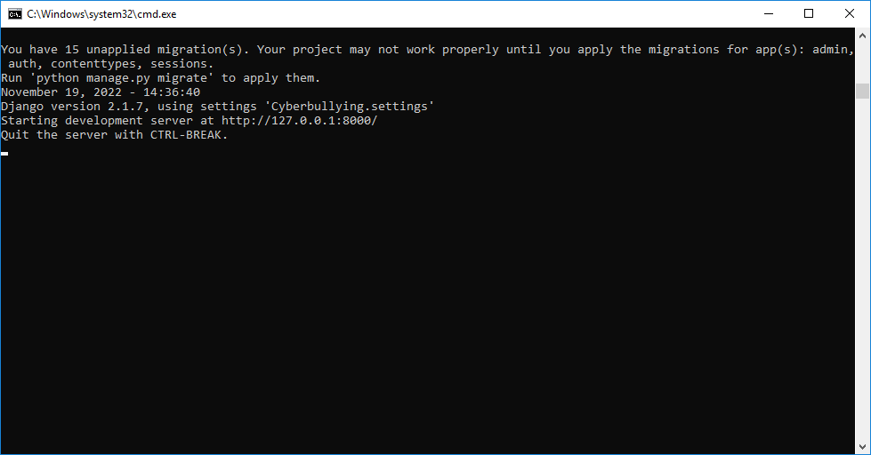
In above screen server started and now open browser and enter URL as ‘http://127.0.0.1:8000/index.html’ and press enter key to get below page

In above screen click on ‘Register Here’ link to get below signup screen
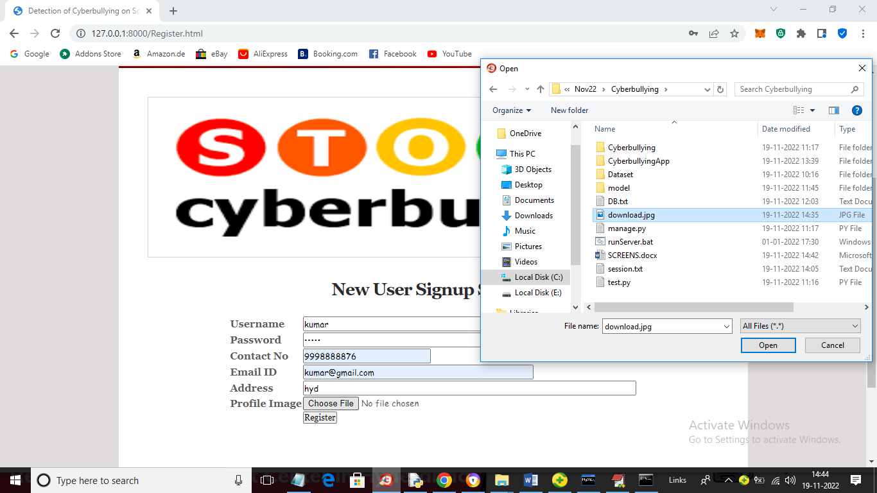
In above screen signup user and then uploading profile picture and then click on ‘Open’ and ‘Register’ button to complete signup task and get below output
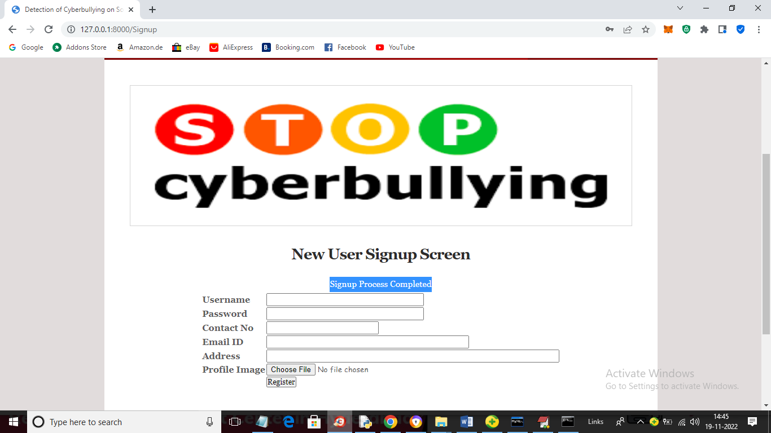
In above screen signup process completed and now click on ‘User Login’ link to get below screen
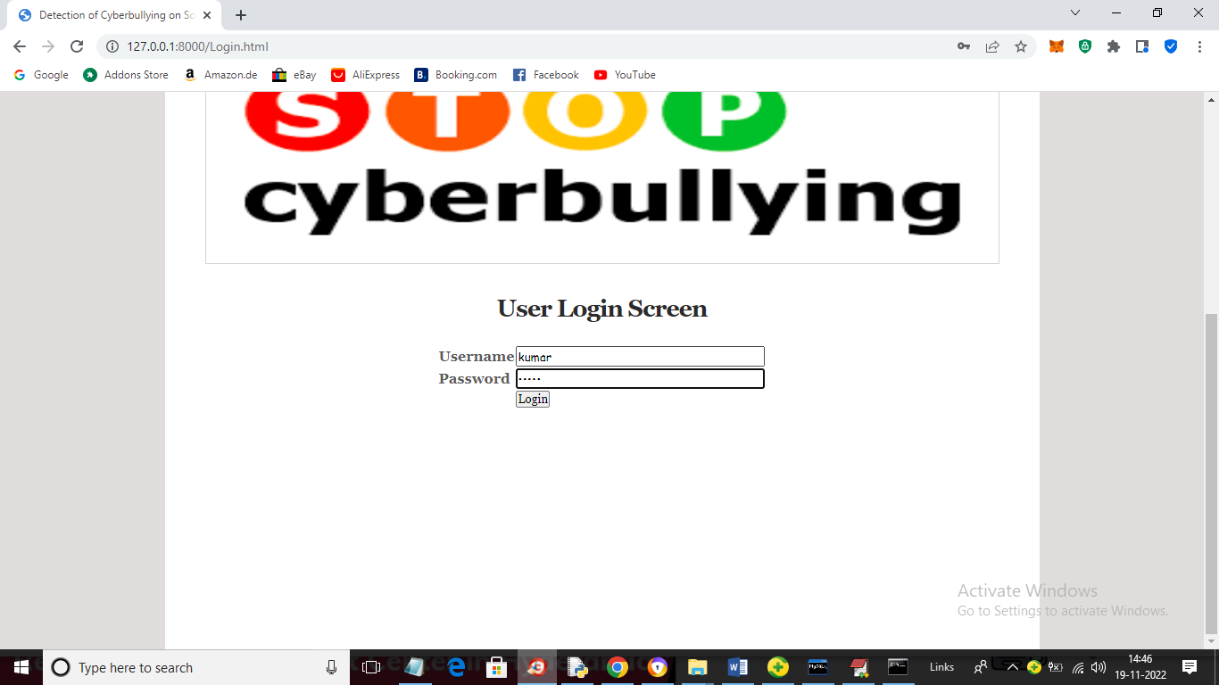
In above screen user is login and after login will get below page
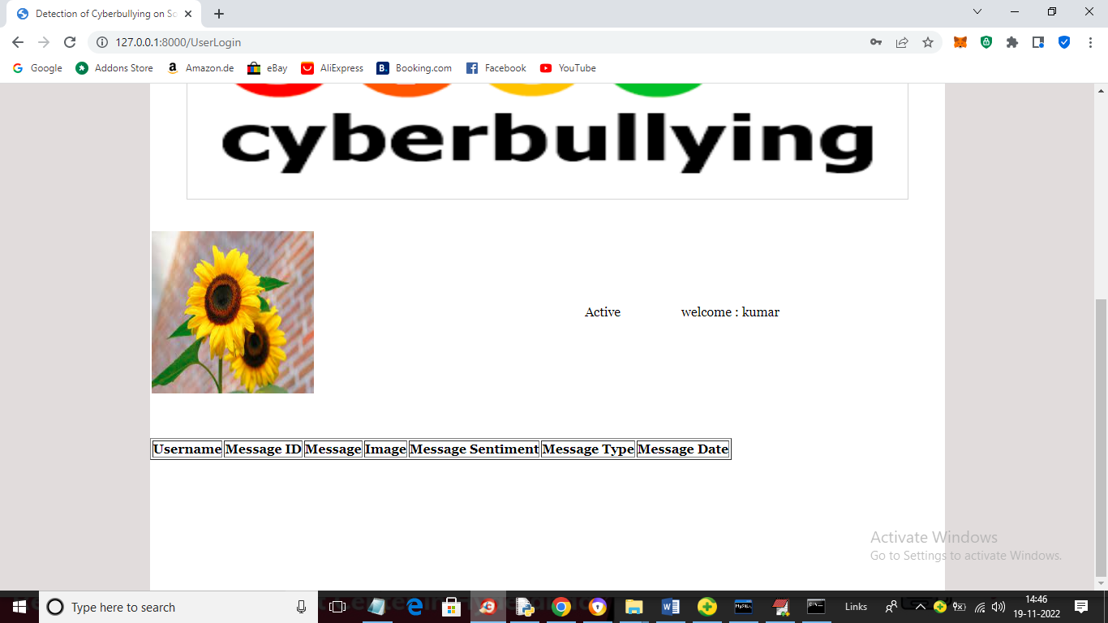
In above screen we can see user profile picture and then can see list of messages posted by user and now no user posted so table is empty and now click on ‘Post Topic’ link to post messages and get below page
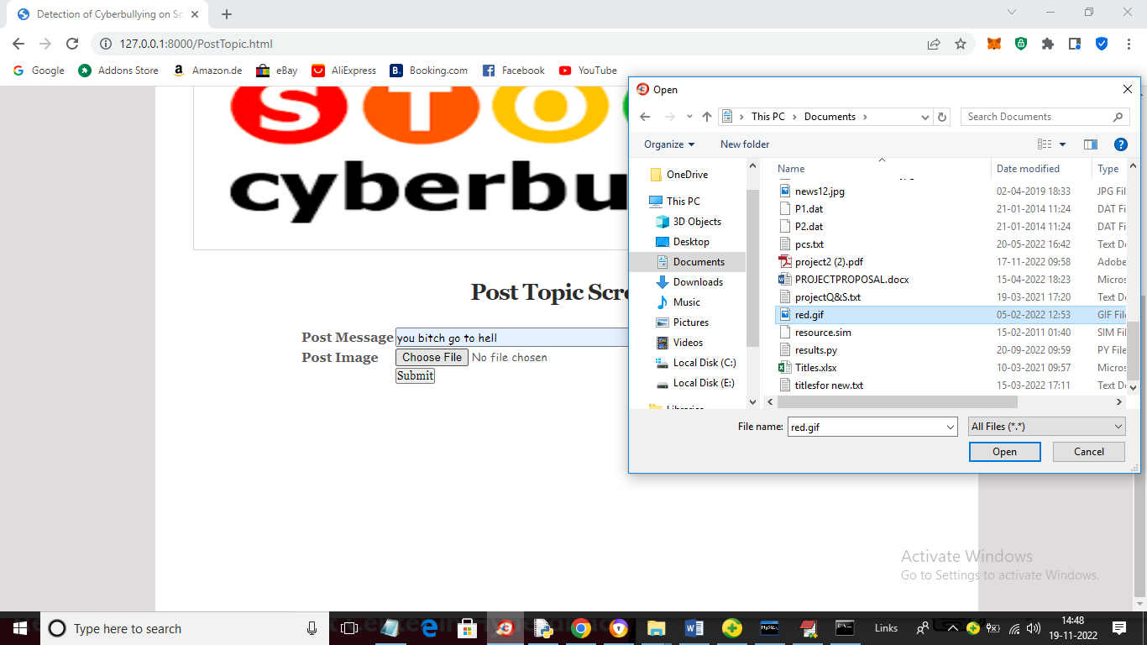
In above screen I entered some message and then uploading image for post and we can see message contains bullying words so will get below output from classifiers
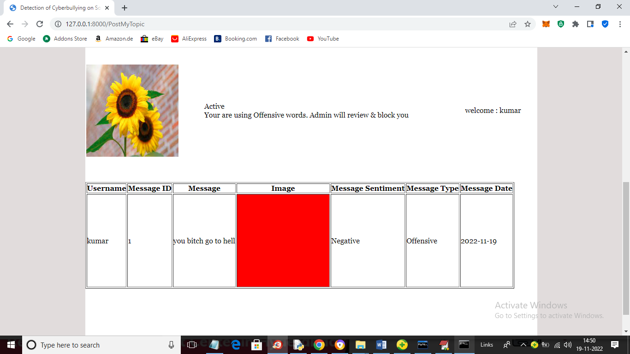
In above screen user message is uploaded and we can see message sentiments detected and Negative and Offensive and now I will upload another post and in above screen we can see application displaying ‘Offensive words are using and admin will block account’. Offensive messages count will get saved in his profile which admin can see.
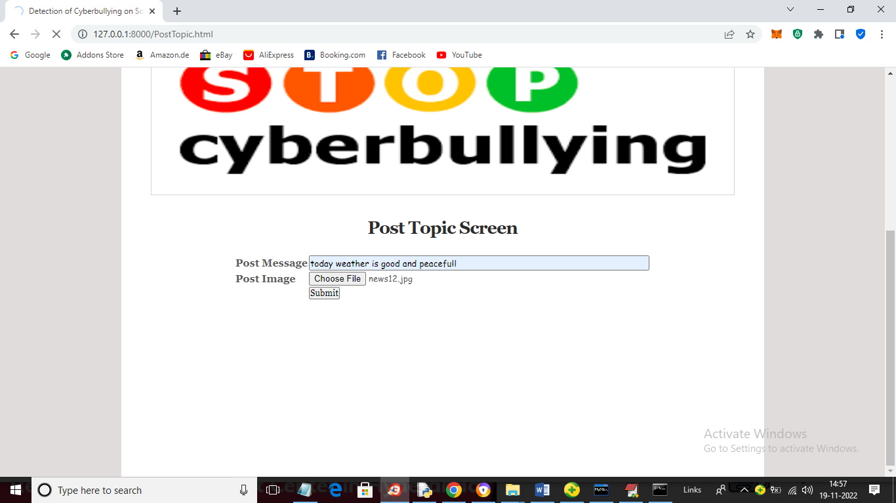
In above screen posting normal message and after analysing will get below output
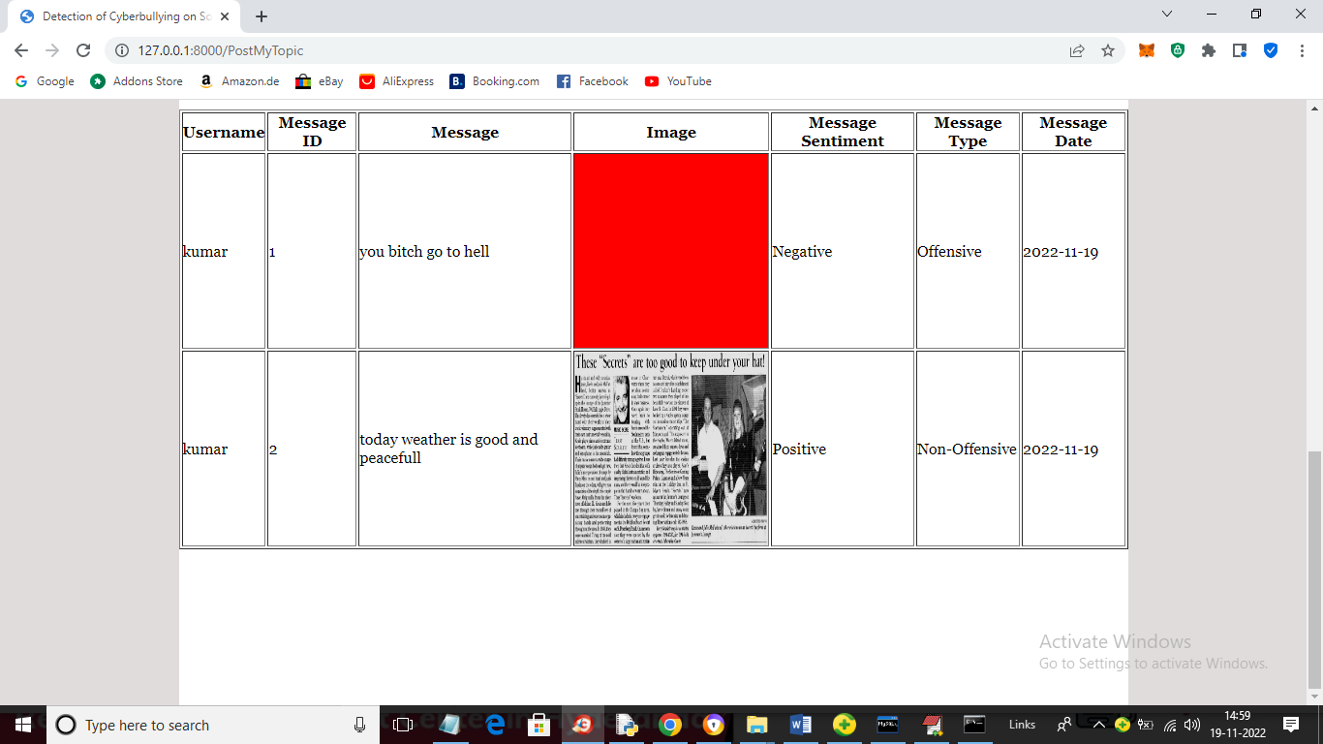
In above screen second message is predicted as ‘Positive’ and ‘Non-Offensive’ and similarly you can upload other messages also. (Note: classifier will predict only those message as offensive or non-offensive whatever available in dataset). Now logout and login as ‘admin’ to view list of users.
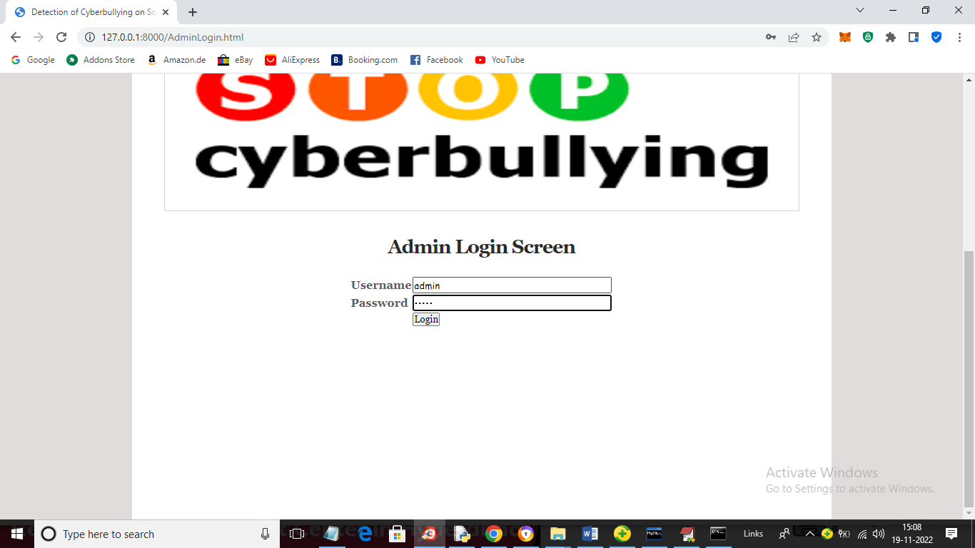
In above screen admin is login and after login will get below page
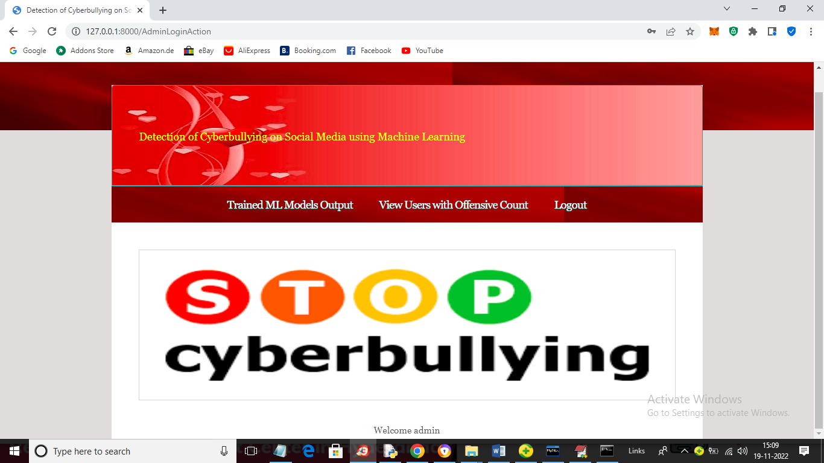
In above screen click on ‘Train ML Models Output’ link to get accuracy and other output
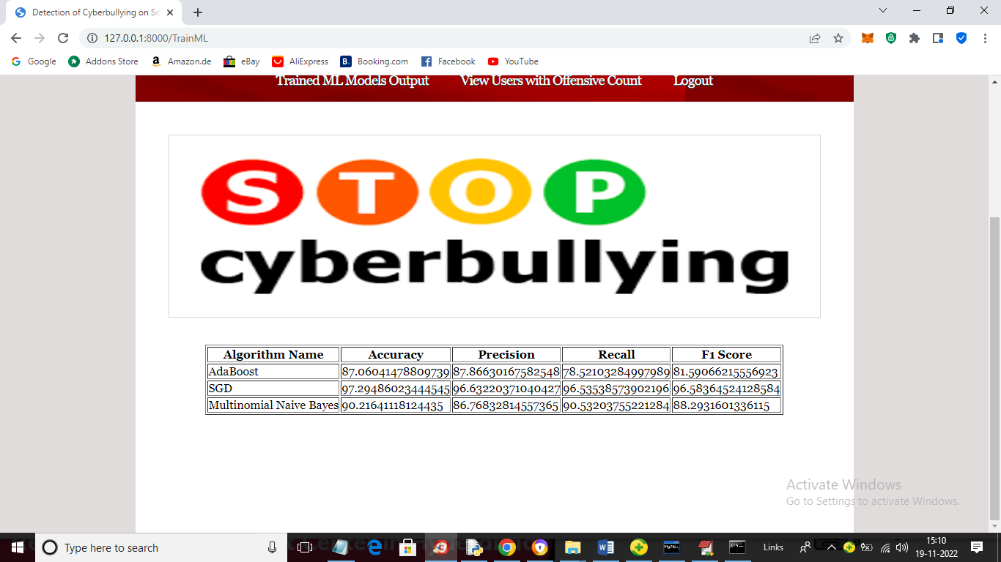
In above screen for each algorithm we can see accuracy and other metrics and now click on ‘View Users with Offensive Count’ link to get below pages
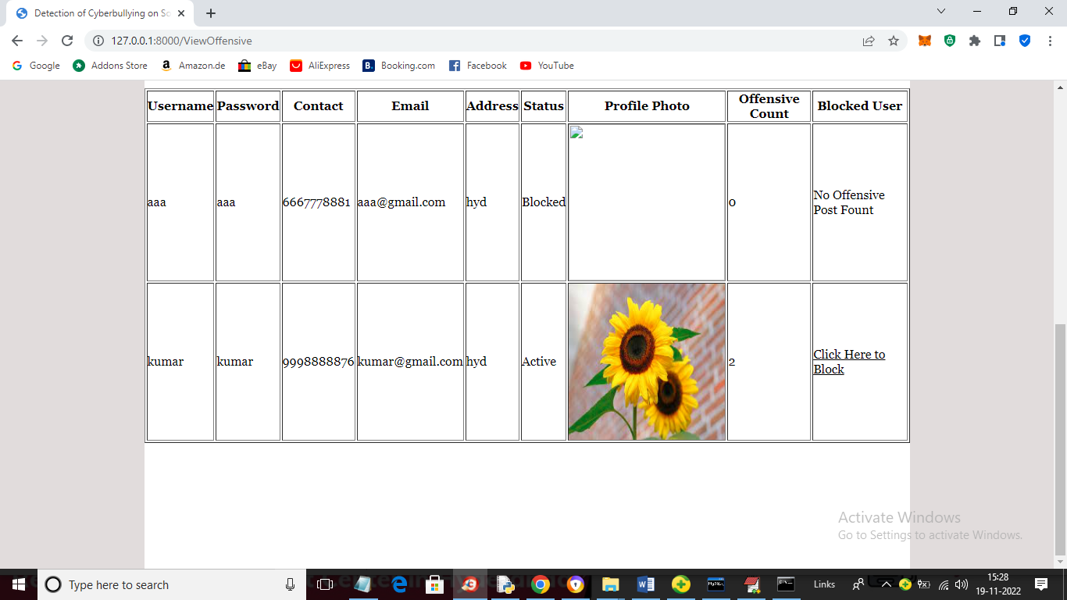
In above screen admin can see one user ‘aaa’ offensive count is 0 and kumar offensive count is 2 and ‘Block’ link activated and admin can click that link to block that user and get below page
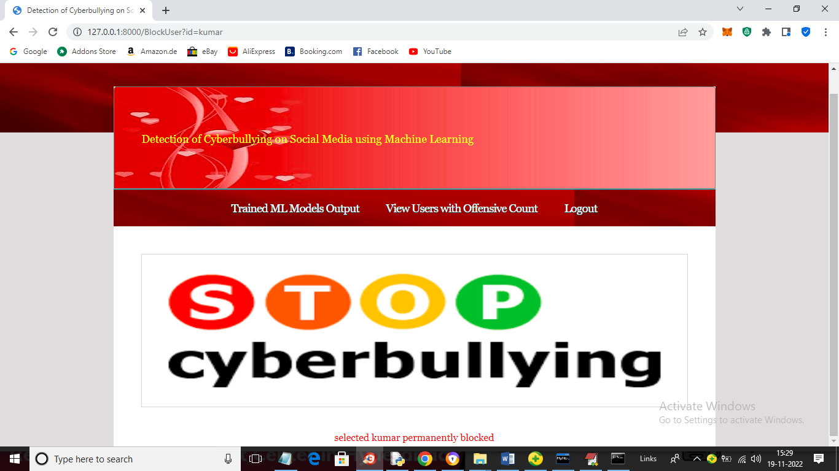
In above screen in red colour text kumar user blocked and now try to login with kumar and get below output
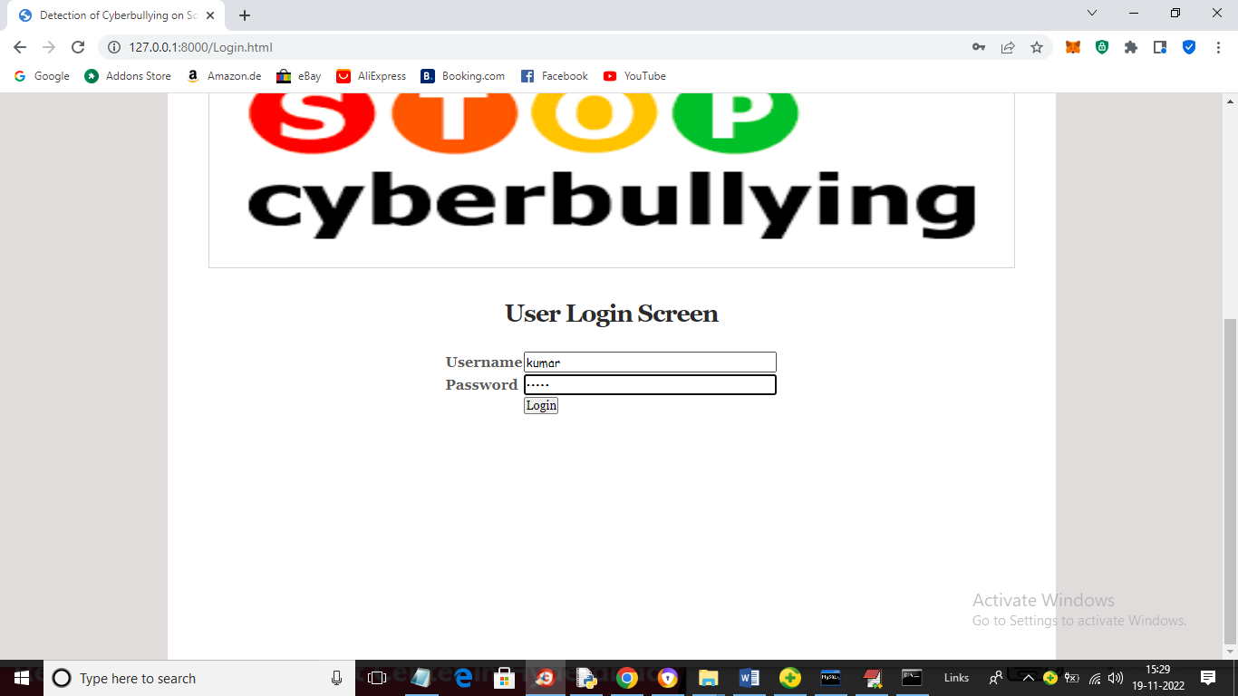
In above screen kumar is login and after login will get below page
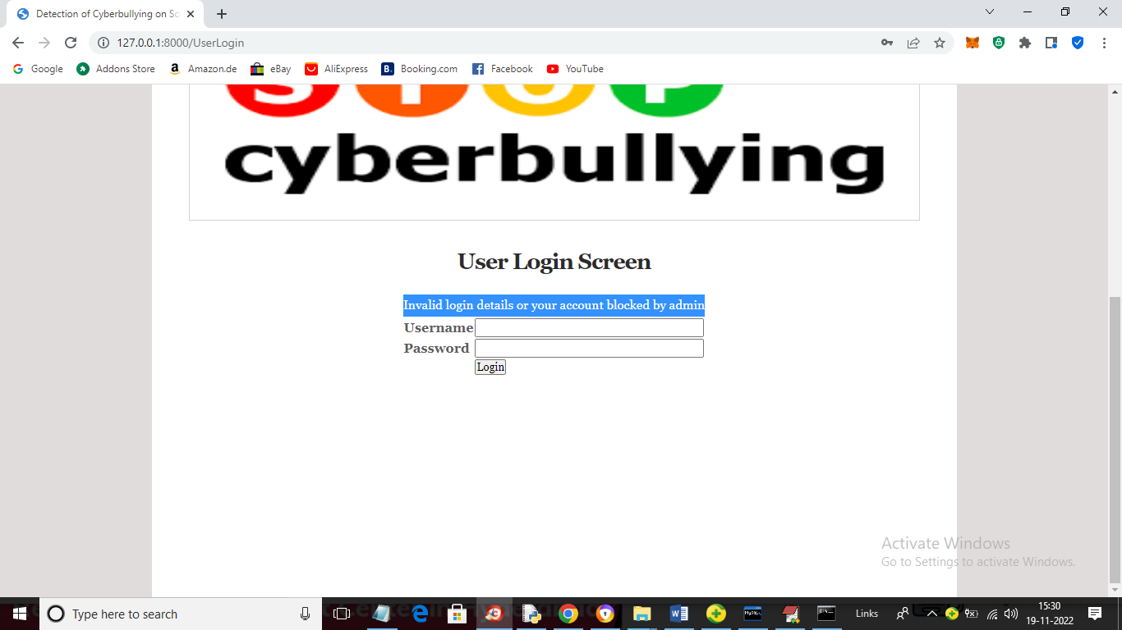
In above screen we can see account is blocked.
Similarly you can post message and detect sentiments and bullying. While uploading messages don’t give special symbol like apostrophy ‘.

8. CONCLUSION
Cyber bullying across internet is dangerous and leads to mishappenings like suicides, depression etc and therefore there is a need to control its spread. Therefore cyber bullying detection is vital on social media platforms. With avaibility of more data and better classified user information for various other forms of cyber attacks Cyberbullying detection can be used on social media websites to ban users trying to take part in such activity In this paper we proposed an architecture for detection of cyber bullying to combat the situation.We discussed the architecture for two types of data: Hate speech Data on Twitter and Personal attacks on Wikipedia.For Hate speech Natural Language Processing techniques proved effective with accuracies of over 90 percent using basic Machine learning algorithms because tweets containing Hate speech consisted of profanity which made it easily detectable.Due to this it gives better results with BoW and Tf-Idf models rather than Word2Vec models However, Personal attacks were difficult to detect through the same model because the comments generally did not use any common sentiment that could be learned however the three feature selection methods performed similarly.Word2Vec models that use context of features proved effective in both datasets giving similar results in comparatively less features when combined with Multi Layered Perceptrons.As seen by changing nature of
9. REFERENCES
[1] I. H. Ting, W. S. Liou, D. Liberona, S. L. Wang, and G. M. T. Bermudez, “Towards the detection of cyberbullying based on social network mining techniques,” in Proceedings of 4th International Conference on Behavioral, Economic, and SocioCultural Computing, BESC 2017, 2017, vol. 2018-January, doi: 10.1109/BESC.2017.8256403.
[2] P. Galán-García, J. G. de la Puerta, C. L. Gómez, I. Santos, and P. G. Bringas, “Supervised machine learning for the detection of troll profiles in twitter social network: Application to a real case of cyberbullying,” 2014, doi: 10.1007/978-3-319-01854-6_43.
[3] A. Mangaonkar, A. Hayrapetian, and R. Raje, “Collaborative detection of cyberbullying behavior in Twitter data,” 2015, doi: 10.1109/EIT.2015.7293405.
[4] R. Zhao, A. Zhou, and K. Mao, “Automatic detection of cyberbullying on social networks based on bullying features,” 2016, doi: 10.1145/2833312.2849567.
[5] V. Banerjee, J. Telavane, P. Gaikwad, and P. Vartak, “Detection of Cyberbullying Using Deep Neural Network,” 2019, doi: 10.1109/ICACCS.2019.8728378.
[6] K. Reynolds, A. Kontostathis, and L. Edwards, “Using machine learning to detect cyberbullying,” 2011, doi: 10.1109/ICMLA.2011.152.
[7] J. Yadav, D. Kumar, and D. Chauhan, “Cyberbullying Detection using Pre-Trained BERT Model,” 2020, doi: 10.1109/ICESC48915.2020.9155700. [8] M. Dadvar and K. Eckert, “Cyberbullying Detection in Social Networks Using Deep Learning Based Models; A Reproducibility Study,” arXiv. 2018.
[9] S. Agrawal and A. Awekar, “Deep learning for detecting cyberbullying across multiple social media platforms,” arXiv. 2018.
[10] Y. N. Silva, C. Rich, and D. Hall, “BullyBlocker: Towards the identification of cyberbullying in social networking sites,” 2016, doi: 10.1109/ASONAM.2016.7752420.
[11] Z. Waseem and D. Hovy, “Hateful Symbols or Hateful People? Predictive Features for Hate Speech Detection on Twitter,” 2016, doi: 10.18653/v1/n16-2013.
[12] T. Davidson, D. Warmsley, M. Macy, and I. Weber, “Automated hate speech detection and the problem of offensive language,” 2017.
[13] E. Wulczyn, N. Thain, and L. Dixon, “Ex machina: Personal attacks seen at scale,” 2017, doi: 10.1145/3038912.3052591.
[14] A. Yadav and D. K. Vishwakarma, “Sentiment analysis using deep learning architectures: a review,” Artif. Intell. Rev., vol. 53, no. 6, 2020, doi: 10.1007/s10462-019-09794-5.
[15] T. Mikolov, K. Chen, G. Corrado, and J. Dean, “Efficient estimation of word representations in vector space,” 2013.

